**Advanced Smoke Group Live Fire Demonstration at the Fire Service College**

18 months ago, Advanced Smoke Group conducted a major demonstration of the capability of a pressurisation system to control smoke in high rise buildings at the Fire Service College at Moreton in Marsh. The demonstration was conducted as part of a seminar held at the college focused on pressurisation and the improved benefits it brought to occupants of high rise buildings in the event of fire.

Since that event, the company have witnessed a significant growth in the level of interest shown in pressurisation systems and the benefits it provides to the escaping occupants of a burning building, and the aid given to fire service personnel entering the building for search and rescue and fire fighting operations. The *Hi.Protect* smoke control system has been of particular interest.

The benefits of pressurisation are already recognised in the draft revision of BS9991, which states that pressurisation should be installed as one key fire safety measure in single stair buildings over 18m in height.

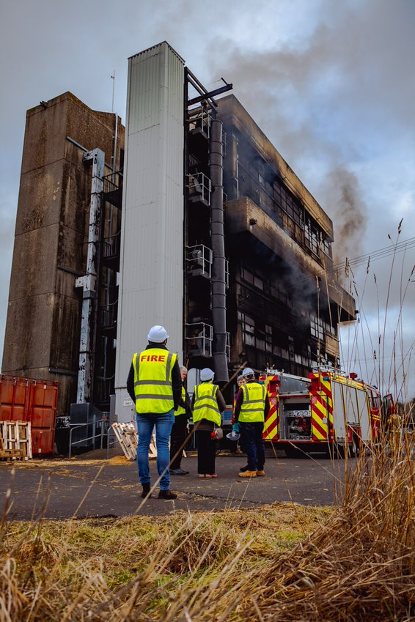

**Figure 1** – The live fire demonstration was carried out in the Indy A Building at the Fire Service college

Delegates from national and local government departments, the fire service and representatives of other fire safety institutions attended the Fire Service College event and were able to witness first hand, how a pressurisation system was able to hold back the heat and smoke from a real fire and enable occupants of the building evacuate safely and in clear air.

For many years, those employed in the smoke control industry have been reluctant, and, in some cases, even outright resistant to the installation of a pressurisation smoke control system. Why?

During the seminar the reasons behind the predominance of the smoke extract system, or depressurisation system, over the past 20 years or so was speculated upon, and the relative performance of the extract and pressurisation systems were compared.

The adverse impact of the British standards and the guidance documents published by trade associations on the popularity of the extract system was significant.

BS 5588 Part 4 *Code of practice for smoke control using pressure differentials*, made the design of such systems complex, not least due to the need to select from an extended list of system types for which the system was to be designed.

Then trade association guides such as the Smoke Control Association, in their guide *Smoke Control to Common Escape Routes in Apartment Buildings*, further highlight perceived difficulties in the design and commissioning of such systems.

**Figure 2** – delegates to the event were able to witness the performance of the pressurisation system from the stairwell

Of course, it has not only been the influence of the published guidance that has adversely impacted on the popularity of pressurisation, the control mechanisms available have been a problem in meeting the standards of performance demanded by standards, such as system response times to changing conditions. Also the available equipment has made commissioning and maintenance of the systems difficult.

Such negative influences have caused engineers less experienced in smoke control design to shy away from embarking upon the use of pressurisation as the most reliable and safe solution of smoke control for high-rise buildings.

As was witnessed by delegates to the live fire demonstration and seminar event, pressurisation is proven to be a highly effective tool in protecting the principal escape routes such as lobbies and stairwells.

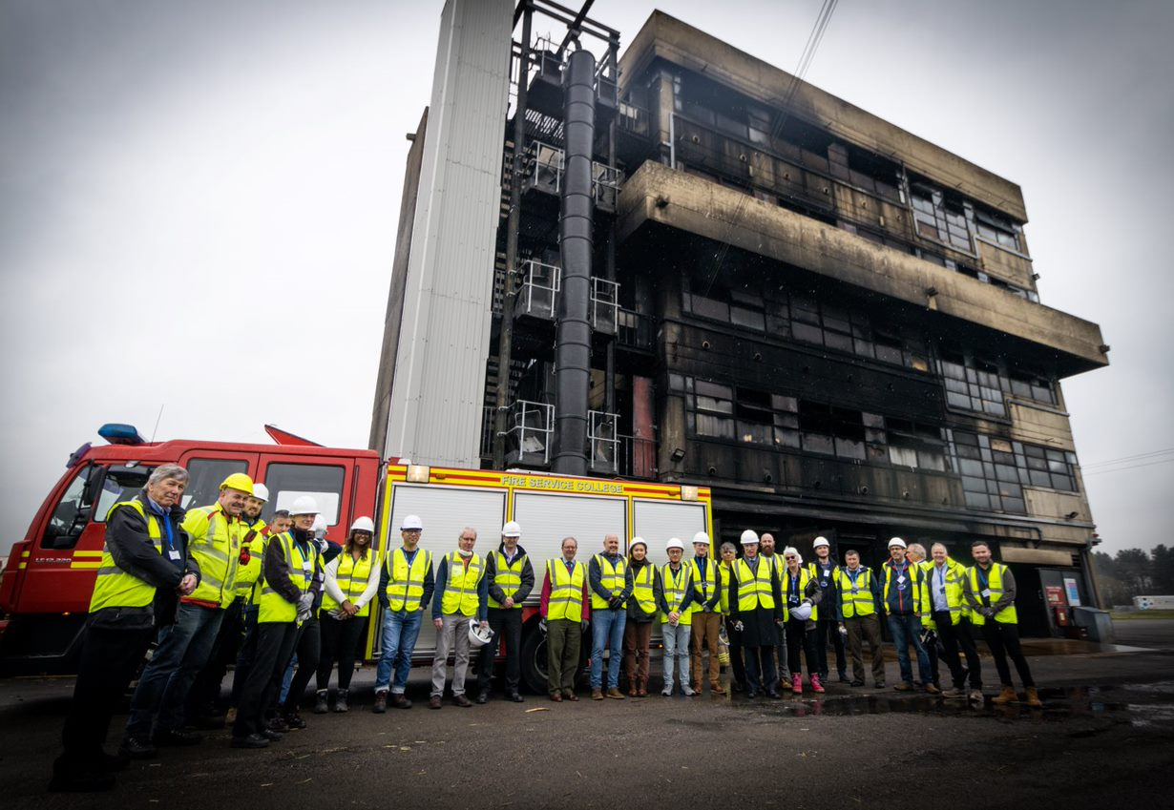

**Figure 3:** Delegates attending the Smoke Control in

Tall Buildings Event

What is an equally important message to those who have, until now, resisted embarking on the design and installation of a pressurisation system, modern control technology makes that type of system just as easy to design, install and commission as a depressurisation system; and it gives better and safer results.