SCR110/20

Report on the current building

regulations and their potential

shortcomings – Car Parks

Advanced Smoke Group Limited March 2020

**Introduction**

As we all know, Approved Document B of the current building regulations is undergoing significant scrutiny and, during the last 12 months, has been subject several amendments; however, the scrutiny has been focused on very specific areas, particularly in the areas of construction.

It is 55 years since the building regulations, originally referred to as the building standards, were published and little appears to have changed in certain areas of the regulations apart from slight editorial “tweaks”. A lot, however, has changed in the type and size of vehicle using enclosed and underground car parks and the type of high rise residential accommodation which is getting taller.

This report is focused on the area of smoke ventilation as it applies to car park ventilation and smoke control in residential buildings which, it is believed, also should be subject to some close examination.

**Car Park Ventilation**

There are two regulations applicable to car parks, Approved Document B3 Section 11 and Approved Document F1 Section 6.18.

Within Approved Documents B & F there are statements of requirements that no-one is likely to be able to provide an accurate or informed answer as to where they came from or on what criteria the stated requirements are based. For example, the requirement for the free area of openings required to support a car park being classified as naturally ventilated.

***Approved Document F***

*Natural Ventilation*

Approved Document F states that 5% of the car park floor area is required in openings directly linked to atmosphere for the car park to be considered as naturally ventilated. 25% of the stated openings should be located on each of two opposing walls. Nothing is said about where the remaining openings should be located.

Alternatively, an “assisted natural ventilation” scheme is an option. In this case 2.5% of the car park floor area must be made available plus 3 air changes per hour provided by mechanical means. The requirements for the distribution of openings is the same, 25% of the openings to be located on each of two opposing walls.

It is difficult to imagine how such a one size fits all natural ventilation scheme can be certain of a reasonable distribution of air and affectively dispersing and clearing the vehicle exhaust gases discharged at low level whatever the geometry of the car park.

Nothing is said within the document about the potential impact of adjacent buildings and the risk of downdraught or air turbulence which could have a detrimental effect on a natural ventilation system as outlined in figure 1. This effect may also be created by geographical features such as an adjacent hillside or even a wooded area.

In the case of an assisted natural ventilation scheme there are no apparent requirements about how the mechanically assisted air change rate is provided, obviously by the installation of a fan located “somewhere” to move air through the car park, but there is no mention of ensuring even distribution of air or that there are no stagnant areas.

**Turbulent air**

+VE

Building in which the

car park is located

+VE

**Figure 1 -** Adverse wind effect caused by adjacent taller buildings

*Mechanical Ventilation*

For a mechanically ventilated car park, an air change rate of 6 air changes per hour. Special attention, however, is paid to ramps, in which case an air change rate of 10 air changes per hour being required due to the ramp being an area of potentially high exhaust pollution concentration.

No particular attention is paid to ramps for naturally ventilated car parks, but maybe more attention should be paid to them by requiring that the entrance to them should have a specific area of opening to them.

It is already mentioned above in connection with naturally ventilated car parks that no reference is made to the distribution of air, or ensuring that there are no stagnant areas in the car park; this same omission applies to mechanical ventilation. More attention should be paid to this important aspect of the ventilation system in order to avoid build-up of pollutant or hazardous gases or vapours in stagnant areas.

***Approved Document B***

***Use of Sprinklers & Alarms?***

Approved Document B3, Section 11.2 states right at the start that *Buildings used as parking for cars and other light vehicles are ultike any other buildings in certain respects which merit some departures from the usual measures to restrict fire spread within buildings. Those are:*

1. *The fire load is well defined and*
2. The fire load is well defined. b. The probability of fire spreading from one storey to another in a well ventilated car park is low. Guidance is therefore given for three ventilation scenarios

Also in Approved Document B5 Section 18 it states that *Car Parks are not expected to be fitted with sprinklers.* The problem is that there can be no control over smoke, temperature or fire spread in a naturally ventilated car park if sprinklers are not installed.

The current regulations consider that ventilation systems serving a car park are not there as part of a life safety system but as an aid to fire fighting. This probably explains why sprinklers are not a requirement despite the potential fire load. It may also explain why there is no requirement for fire detection or an alarm system.

It is also the case that only in the redrafted BS7346: Part 7 published in 2013, that the standard required automatic activation of a mechanically ventilation system. Thankfully, the more enlightened of the fire engineers are now specifying that a fire detection system is required within mechanically ventilated car parks.

However, neither fire detection nor alarm systems are a requirement in the regulations and the potential for fire spread within a large open sided car park was very clear to see in Liverpool, see figure 2.

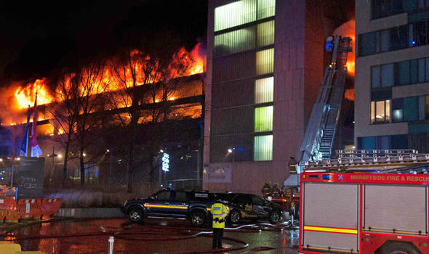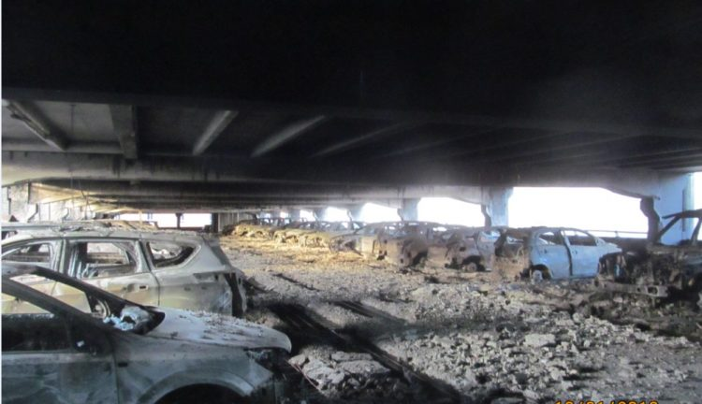

**Figure 2** – There is no control over smoke, temperature or fire spread in a naturally

ventilated car park if sprinklers are not installed.

The consequence of having the combination of uncontrolled ventilation, i.e. natural ventilation, and no control over temperature or smoke flow as is the case in a naturally ventilated car park is a dangerous mixture. This is particularly hazardous in situation in the event of fire in one of the steel structure multi-level car park which employ a steel plate platform between levels; heat will quickly transmit to the tyres, paintwork and even fuel tanks of the vehicles parked on levels above the fire. The consequences were seen recently in Stavanga, see figure 3.

***Natural Ventilation***

In Approved Document B3 Section 11, it states that 2.5% of the floor area is required in openings linked directly to atmosphere for a naturally ventilated car park in order to provide for smoke clearance in the event of fire. 50% of the available openings should be split equally between two opposing walls.

Just as in the case of the requirements of Approved Document F, this requirements is quoted without any justification.

The reduced area of 2.5% with no mechanical assistance in the event of fire might be explained as the buoyancy of the gases will assist in the venting of the smoke, but where does the 2.5% come from? If the 2.5% of car park area in ventilation openings could be justified against a fire load fifty years ago, but vehicles and the level of fire risk has also increased significantly.

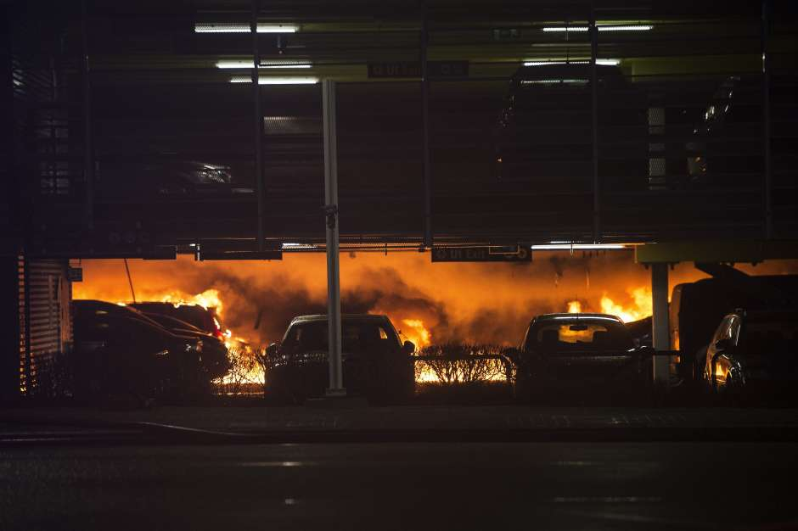 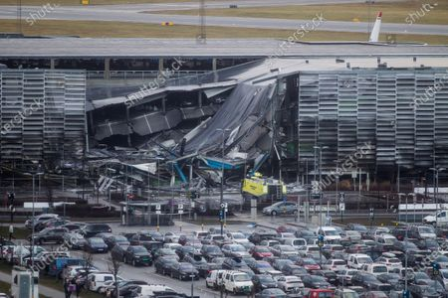

**Figure 3** – Fire spread quickly between vehicles and between levels in the car

park at Stavanga airport which was of steel construction throughout

**Mechanical Ventilation**

The requirements for a mechanical ventilation system is quite clear within the standard, but the performance criteria is still questionable. The figures for air change rate of 10 air changes per hour in the event of fire appears a little arbitrary.

This figure applies whether the car park is 500m2 or 5,000m2, but the potential fire load will be similar, at least according to BS7346: Part7 and the BRE Research that was undertaken some years ago into car park fires.

However, the document does refer the reader to BS7346: Part 7 for further guidance, though it refer to the 2006 instead of the 2013 version which gives away how long it is since the document was reviewed. BS7346: Part 7: 2013 provides guidance for providing smoke control

Whilst many aspects of a life safety system are required in the regulations such as dual power supply, fire rated cabling and high temperature ratings for the fans, there are a number of areas in which there are relaxations. Only two fans are required each rated at 50% of the maximum designed airflow. This means that, if a fan fails during a fire, the resultant airflow will be only around 50% of the design flow, whereas in a full life safety system there would be two fans each at 100% design airflow with one operating and one standby or three fans at 50% with two operating and one as a standby.

Inevitably, in many mechanical systems attenuation will be installed in the extract fan chambers and, whilst there is a requirement for ducting and its fixings to meet a stated performance criteria, there is no mention in the approved document of a requirement for ancillary equipment. It is likely therefore, that attenuation that has not been designed to withstand high temperatures has been and will be installed in “value engineered” projects.

**Other considerations**

There is no guidance provided in the regulations relating to the ventilation of loading bays, although BS9999 refers to the Smoke Control Association (SCA) publication giving guidance on the venting of loading bays and coach parks.

The SCA document refers to the adoption of 2.5% of the floor area of the loading bay for venting smoke in the event of fire and this appears to have been be an acceptable solution to regulators irrespective of the fact that there is likely to be a substantially larger potential fire load within a loading bay to that of a car park.

For example, the typical design fire load in a car park is 8MW, for a loading bay it will be nearer 40MW, yet the same ventilation area is accepted for a similar sized parking area. And we still do not know where the 2.5% figure comes from.

**Conclusions**

Since the introduction of the large multi-level car parks which are now forming an integral part of high rise residential apartments as well as shopping centres and office blocks, it is time to look more closely at this forgotten area of the building regulations. It is an area which could potentially create a serious risk to life and maybe the ventilation systems installed for the larger high density car parks, should be re-classified as being considered as life safety systems.

It may also be prudent to consider the inclusion in the approved documents, both ADB and ADF, reference to electric vehicles and the potential new hazards related to these, particularly in connection to vehicles that are hooked up to charging points and vehicle fire risks. Reference to Advanced Smoke Group report SCR108/19/R4 might be useful in connection with these subjects.

Maybe also the approved document could include a statement requiring witnessed commissioning and practical demonstration of key areas of performance rather than regulators relying on CFD models for verification of design. CFD models are a useful aid to design, but they cannot possible incorporate all the features of a car park installation, including all the ductwork, cable trays, drainage pipes, beams and other services which occupy a car park.

© Copyright Advanced Smoke Group Limited

Advanced Smoke Group Limited, 46 Kenilworth Drive, Oadby, Leicester, LE2 5LG

www.advancedsmoke.co.uk